**Capstone Project Step-by-Step Solution**

Task

**6**

Work with the Report Designer to create a report which displays the number of incidents that are active and tied to the sFone category. Additionally, group the data by priority.

Schedule the report by sharing it with the Strawberry Support group every Monday to coincide with their incident review meeting.

**Refer to** Module 5: Enable Productivity

# Create a Report

## Navigate to Reports > Create New.

The Report Designer displays. Notice the process begins in the **Data** step.

1. Add the Report name: **Active sFone Incidents by Priority**.
2. From the Source type drop-down, select **Table**.
3. Select **Incident [incident]** as the Table.

1. Click **Next**.

You should now be in the **Type** step. Scroll down to select your visualization. For this report, you will use a **Pie chart**.

* 1. Click the **Pie chart** under Pies and Donuts

* 1. Click **Next** to continue to the **Configure** step.
  2. From the Group by drop-down, select **Priority**.

* 1. Click **Run** to display your report.

You can hover over and select each section of the pie chart to get a closer look at the data.

* 1. Select the **funnel** icon to open the Condition Builder.

* 1. Add the condition:

**Category | is | sFone**

* 1. Click **Run**, then close the Condition Builder by clicking on the Close Filter (**X**) icon.
  2. Click **Save**.

**NOTE:** Clicking Save in the Report Designer will automatically refresh (run) the report.

# Schedule the Report

Now that the report has been created, any new data that is collected in the instance matching the filter requirements will display when the report runs. Scheduling the report will allow this information to be shared with the appropriate stakeholders.

1. With the Active sFone Incidents by Priority report open in the Report Designer, open the **Share** menu by clicking the **Sharing** icon.

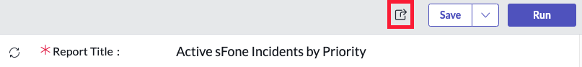

1. Select **Schedule** from the Sharing menu.

1. Populate the form as follows:

Groups: **Strawberry Support**

Run: **Weekly**

Day: **Monday**

Time: **08:30:00**

Subject: **Current sFone Active Incidents Count**

Introductory message:

## Please find included the current count of all active sFone incidents grouped by priority. This information will be discussed during the team’s incident review meeting today at 9:00am.

1. Click **Submit**.

TASK VERIFICATION

Confirm the report appears as follows and is scheduled.

